|  |  |
| --- | --- |
| **Job title**: Sports Development and Participation Officer | |
| **Classification**: Band 7 | **Effective Date**: April 2025 |
| **Reports to**: Coordinator Active Communities | **Tenure**: Temporary |

# About Us:

At Whitehorse City Council, community is at the heart of everything we do.

We aspire to be a healthy, vibrant, prosperous and sustainable community. We enable this through strong leadership and community partnerships.

We strive to stay ahead of evolving changes and needs of our community.

Our five key principles empower our employees to be innovative and provide an excellent customer experience. We are a resilient organisation where everyone belongs.

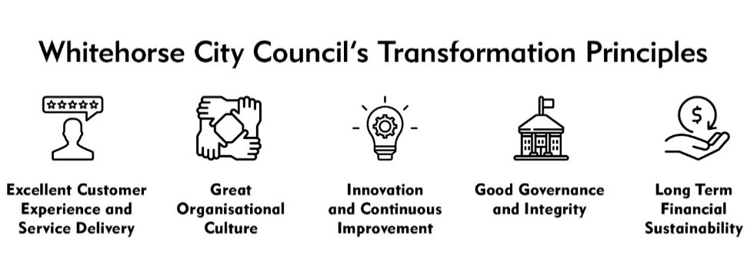

# CREATe - Our Values and Behaviours:

Our shared values and behaviours are integral to how we go about our work, interact with each other and our community. Our employees ‘live’ these shared values. In living these values we also ensure that everyone has a voice and that everyone matters.

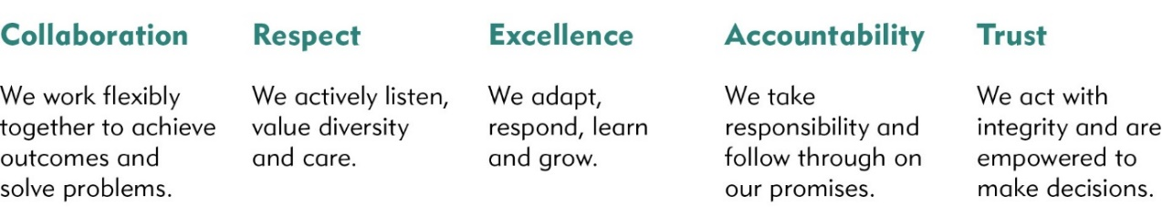

City of Whitehorse is a culturally and linguistically diverse community. We are proud of the diversity of our workforce and recognise the strength this provides in meeting the needs of our community. We are committed to upholding a safe, inclusive and respectful workplace that values the contribution of all.

Whitehorse City Council is committed to being a child safe organisation. We recognise our responsibilities to keep children and young people safe from harm and have established policies, procedures and training to achieve these commitments.

# Goal Statement

# The Leisure and Recreation Services Department’s mission is to empower, activate and connect our community.

# The position is responsible for proactively planning and managing current and future utilisation of Whitehorse sport and recreation facilities, with a particular focus on sport and recreation organisational capacity perspective. The role focuses on growing the quantity, quality and diversity of physical activity participation, and improving health and wellbeing outcomes for the community.

# This role will involve significant interaction with sport and recreation stakeholder representatives, management, and other relevant staff throughout the Council. The role will focus on undertaking research, promotion, development of recreation strategy and policy and supporting the subsequent implementation of action plans and other relevant initiatives of Leisure and Recreation Services.

# Key Responsibilities

## Position Specific Responsibilities

* Support the volunteer community sport and recreation club model in Whitehorse and explore organisational capacity building through club development in the municipality within existing resources.
  + Plan and deliver Council’s initiatives such as the All Sports Newsletter, Club Development Forum of workshops and other education opportunities
  + Proactively liaise with clubs through meetings and other opportunities, supporting their sustainability through health checks and development of action plans for their operations
  + Support Council’s relationship with regional sporting associations along with the Recreation Services Officer
* Implement key projects contained within Council’s strategic priorities
* Work to grow and enhance female sport and recreation participation in Whitehorse through implementation of the actions of the Whitehorse Fair Access Policy Action Plan, including leading and supporting Council’s approach to conducting Gender Impact Assessments for all relevant projects and priorities across departments as they relate to Leisure and Recreation Services
* Contribute to the collation and analysis of participation data for physical activity in Whitehorse and other relevant industry trends and share findings with relevant stakeholders
* Maintain extensive knowledge of the current operating environments of Whitehorse sport and recreation clubs and other stakeholders including their opportunities, challenges and their perception of Council’s support of their activities
  + Develop and administer the annual Whitehorse Sporting Club Satisfaction Survey and implement actions upon recommendations found
* Provide specialised advice to internal and external stakeholders regarding matters impacting community sport and recreation in Whitehorse (e.g. Community Infrastructure Plan and implementation, Indoor Sports or similar strategies, open space master plans, capital works planning, sporting risk matters and facility suitability)
* Consult and collaborate with key community groups such as sports associations and clubs to educate and manage expectations around the delivery of facilities for community sport and recreation.
* Assist Council effectively manage club growth and its impact upon the delivery of public facilities and broker improved outcomes in the community through holistic analysis and proactive stakeholder communication about facility sharing and/or club mergers as required
* Explore promotion/marketing opportunities for Council activities and facilities and support existing initiatives and campaigns advocating for greater opportunities in sport, recreation and leisure.
* Build partnerships with community health providers, not-for-profit organisations and businesses and work together to resource initiatives within community sport and recreation settings that deliver positive health and wellbeing outcomes
* Facilitate funding/grants processes, supporting clubs to access and gain external funding and to promote and encourage active communities.
* Support the development and execution of various sport and recreation lease agreements or related documented arrangements as required.
* Represent Council as a key advocate on eastern region and other projects in the development of sports strategies and sporting codes.
* Manage important relationships both internal and external in a political and demanding Leisure and Recreation Services Department.
* Proactively seek to develop and maintain relationships with sporting groups and associations within the municipality and the broader area.
* Any other related duties as directed.

## Corporate Responsibilities

* Adhere to all Corporate Policies, Procedures and the Organisational Goals and Values in the current Whitehorse City Council Collective Agreement.
* Understand and adhere to the Risk Management Policy (as it relates to the employees work area) and related procedures that are designed to minimise injury and/or loss to individuals, assets and equipment.
* Report any matters that may impact on the safety of Council employees or citizens, assets and equipment.

# Accountability and Extent of Authority

**Budget:** Provision of budgetary and project advice, monitoring and delivery of Leisure and Recreation projects within budget.

**Staff responsibility:** Casual and temporary staff from time to time, contractors and consultants deemed relevant and related to projects undertaken by the incumbent. Support and guide other departmental staff in their development. Provide support and guidance to student placements and interns.

**Judgement and Decision Making**

* Formulate strategies and policies following analysis of options that respond to a range of complex issues.
* This position is generally responsible for creating a framework that will ensure projects meet relevant timeframes, budget constraints and customer expectations and there is relative flexibility in the position to ensure that this occurs.
* The ability to exercise sound judgement with minimal supervision and manage own workload is essential. Able to complete tasks within required timeframe and to the required standard despite conflicting pressures. Awareness of and compliance with Council policy and procedures and relevant industry standards is essential.

# Specialist Knowledge and Skills

* Ability to proactively research, synthesise and understand information relevant to sport and recreation relating to Whitehorse
* Advanced relationship management skills and ability to negotiate positive outcomes for Council and the community
* Proficiency in developing considered and complex policy and strategic outputs
* Possess advanced communication skills including the preparation of high quality written reports and presenting to various audiences
* Knowledge of and ability to work in keeping with relevant legislation and other regulations
* Proficiency in the use of contemporary technology and software and/or possessing the aptitude to develop skills as required to fulfill role requirements

**Qualifications and Experience**

* Tertiary qualifications in Recreation, Sport, Leisure Studies, Planning, Project Management or a related discipline combined with project management experience.
* Substantial experience with policy and strategy development in a community/recreation/leisure based setting with an emphasis on stakeholder management, ideally in local government.
* Experience and knowledge of community / societal health and wellbeing, club development, governance, participation, growth and industry trends (sport, recreation, leisure) is desirable.

**Interpersonal Skills**

* Ability to gain cooperation and assistance of other staff, the community and external agencies to discuss and resolve specialist problems and achieve desired outcomes for the City.
* Excellent facilitation skills to enable the successful management of consultation processes and stakeholders to achieve project outcomes.
* Ability to work in a politically charged environment, dealing with sensitive information and community groups
* Ability to develop and maintain effective working relationships with internal and external stakeholders
* Highly effective interpersonal skills, incorporating written and verbal communication, facilitation, collaboration and partnership.
* Highly effective communication, mediation and conflict resolution skills.
* Ability to work autonomously and in a team environment and high quality facilitation skills to drive and facilitate meetings, forums and stakeholder discussions

# Key Relationships:

* The incumbent liaises with Councillors, management and staff at all levels up to and including Directors and the Chief Executive Officer and provides advice on all issues pertaining to Leisure, Parks Planning and Recreation.
* Required to negotiate and influence and maintain professional relationships with Government departments, community agencies, project stakeholders, steering groups, consultants, other Municipalities, service providers, staff associations, suppliers, community groups, sports clubs, business groups and customers.

**Management Skills**

* Ability to manage a variety of complex tasks concurrently.
* Ability to develop and implement organisational planning and design policy and contribute to the development of corporate policy.
* Ability to influence sensitive community groups, steering projects to achieve desired outcomes whilst working resiliently and autonomously (sports associations, clubs, residents).
* Proven ability to manage, mentor and motivate key stakeholders in achieving identified project outcomes and shared decision making.

**Application Requirements**

* Satisfactory National Criminal History Check.
* Working with Children Check.
* A valid Victorian driver’s licence (desired)

# Key Selection Criteria

1. Tertiary qualifications in Recreation, Sport, Leisure Studies, Planning, Project Management or a related discipline combined with experience in project management, the development of policy and strategy in a community / sport / recreation / leisure-based setting and advanced technical skills to deliver these outputs
2. Thorough understanding of community consultation, project management techniques and principles and the demonstrated capacity to deliver quality projects on time and within budget.
3. Highly developed interpersonal, facilitation, consultation, negotiation and engagement skills, and the ability to negotiate and problem solve. This includes experience working with engaged stakeholders
4. Extensive knowledge of community / society health and wellbeing trends, sport and recreation club development, governance, participation, growth, industry trends and challenges.
5. Ability to build productive stakeholder relationships to work in partnership with, influence, educate and manage expectations of state, regional and local sports associations and sports clubs in the provision of sport and recreational facilities and activities

# Physical Requirements

| Physical Functional Demand | Specific Physical Job Tasks | Frequency/Duration of performance of task per day | *Comments* |
| --- | --- | --- | --- |
| Kneeling/Squatting  Tasks involve flexion/bending at the knees, ankle, and waist in order to work at low levels. |  | Performed Sometimes |  |
| Hand/Arm Movement  Tasks involve use of hand/arms |  | Performed Sometimes |  |
| Bending/Twisting  Tasks involve forward or backward bending or twisting at the waist. |  | Rarely Performed |  |
| Standing  Tasks involve standing in an upright position |  | Performed Sometimes |  |
| Reaching  Tasks involve reaching above head, and above and equal to shoulder height |  | Performed Sometimes |  |
| Walking  Tasks involve walking on slopes and walking whilst pushing/pulling objects |  | Performed Sometimes |  |
| Lifting/Carrying  Tasks involve raising, lowering and moving objects from one level position to another |  | Performed Sometimes |  |
| Pushing/Pulling  Tasks involve pushing/pulling away, from and towards the body |  | Rarely Performed |  |
| **Keyboard Duties**  Tasks involve sitting at workstation and using computer. |  | Performed Often |  |
| **Satisfactory Vision**  Standard of vision required equal to that required for driver’s licence |  | Performed Sometimes |  |

Any other relevant comments:

* Short listed candidates may be required to attend a pre-employment medical examination.
* The position will require working from different locations within the municipality and will be required to attend out of hours meetings from time to time.