Job title: Senior Recreation and Open Space Project Manager
Classification: Band 8 | Effective Date: May 2023
Reports to: Coordinator Recreation and Open Space Development | Tenure: Full Time to 30 June 2024

About Us:
At Whitehorse City Council, community is at the heart of everything we do.
We aspire to be a healthy, vibrant, prosperous and sustainable community. We enable this through strong leadership and community partnerships.
We strive to stay ahead of evolving changes and needs of our community.
Our five key principles empower our employees to be innovative and to provide an excellent customer experience. We are a resilient organisation where everyone belongs.

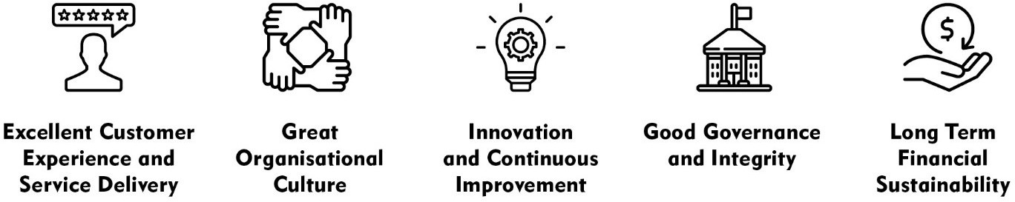

CREATe - Our Values and Behaviours:
Our shared values and behaviours are integral to how we go about our work, interact with each other and our community. Our employees ‘live’ these shared values. In living these values we also ensure that everyone has a voice and that everyone matters.
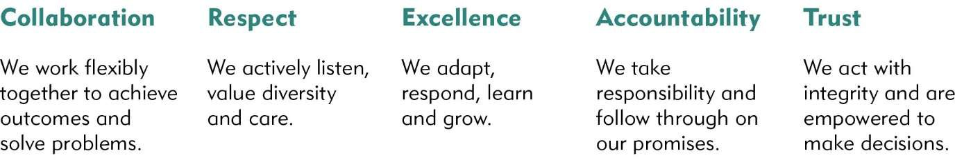

Goal Statement
The Leisure and Recreation Services Team’s mission is to Activate and Connect our Community. The Senior Recreation and Open Space Project Manager role will provide Council with high quality project management of recreation and open space master plans, operational and capital works projects that reflects current and future needs of the community.

Key Responsibilities
Position Specific Responsibilities
- Plan, facilitate and coordinate the delivery of innovative and high quality recreation and open space master plans that reflect the current and future needs of the community.
- Development of tender documentation, contracts and negotiated agreements in relation to capital project plans and strategic feasibility studies.
- Identify, analyse and provide innovative solutions to issues and challenges in a demanding growth environment, and assist work teams to resolve issues and realise opportunities.
- Provide strategic advice to internal and external stakeholders on recreation and open space matters and projects.
- Provide leadership, support and direction to staff and create an environment that promotes high performance and professional development.
- Prepare innovative Council reports, project briefs, grants and other technical documentation for written and oral presentation in a timely manner.
- Lead skilled community and stakeholder consultation processes to identify community needs, and develop appropriate strategies to meet those needs.
- Initiate and manage the development of planning and design projects.
- Support the delivery of Capital Works project and programs, formulation of the annual budget and monitoring of project budgets using Council’s financial management systems to ensure compliance and to reflect the most up to date and accurate status of projects.
- Other duties at required

Corporate Responsibilities
- Adhere to all Corporate Policies, Procedures and the Organisational Goals and Values in the current Whitehorse City Council Collective Agreement.
- Understand and adhere to the Risk Management Policy (as it relates to the employees work area) and related procedures that are designed to minimise injury and/or loss to individuals, assets and equipment.

- Report any matters that may impact on the safety of Council employees or citizens, assets and equipment.

Accountability and Extent of Authority
Budget: Provision of budgetary and project advice and monitoring and delivery of recreation projects within budget.
Procurement: Ability to understand and follow Council’s procurement policies and procedures.
Staff responsibility: The position is responsible for the management of consultants providing services relating to recreation and master planning. The position will provide support to the Coordinator to lead and development team members.

Judgement and Decision Making
- The position requires decision making based on an understanding and knowledge of Council’s goals and objectives.
- Independent judgement and adaptability is required in evaluating and deciding on appropriate methods, procedures and practices for achieving objectives.
- Ability to think laterally and provide innovate responses and recommendations to achieve beneficial outcomes for Council and the community based on sound judgement, research and consultation.

Specialist Knowledge, Qualifications and Experience
- Tertiary qualifications in recreation, leisure studies, planning, landscape architecture, project management or a related discipline combined with significant experience in recreation and open space and project management within a Local Government context.
- Extensive experience in community recreation and leisure development, strategy development, service and project management.
- Knowledge and understanding of recreation planning and infrastructure development.
- Sound technical, and strategic planning capabilities.
- Strong analytical and investigative skills including ability to translate and communicate information to a wide range of stakeholders.
- Extensive experience of recreation and open space planning and design focus experience and a commitment to quality outcomes.
- Thorough understanding of planning and project management techniques and principles and the demonstrated capacity to deliver quality projects on time and within budget.

- An understanding of the long-term goals and values of the organisation with a high degree of political acumen and appreciation of the local government environment.
- A valid Victorian driver’s licence.
- Satisfactory National Criminal History Check.
- Working with Children Check.

Technology:
- Competence in the use of computers and a variety of relevant computer software such as Microsoft Word, Excel, Outlook, GIS. Skills in the use of AutoCAD and Adobe Creative Suite or similar are desirable but not essential.

Interpersonal Skills
- Excellent written and oral communication skills to enable preparation of comprehensive and accessible reports, presentations and correspondence.
- Ability to build and maintain effective working relationships with Council departments, Councillors, sporting clubs, professional bodies and other key stakeholders.
- Ability to negotiate and liaise effectively with internal and external stakeholders to achieve community outcomes.
- High level skill in managing community consultations including excellent facilitation, negotiation, problem solving, relationship management and advocacy skills.

Key Relationships:
- Internal Liaisons: Liaises with and advises staff at all levels up to and including Directors, the Chief Executive Officer and Councillors.
- External Liaisons: The incumbent is required to liaise with, consult and maintain a professional relationship with Government agencies, other municipalities, consultants, professional associations, community groups, sporting clubs and residents.

Management Skills
- Ability to effectively plan, prioritise and manage multiple tasks in a changing environment to achieve targets within tight timelines and adapt to urgent priorities.
- Ability to lead and motivate team members to achieve required outcomes.
- Capable to managing complex collaborative projects including multiple partners from across the organisation, consultants, contractors and the community.
- Project manage the development of master plans and other nominated operational and capital works projects.

- Prepare Council reports, project briefs and other technical documentation for written and oral presentation.
- Facilitate skills consultation processes.

Notes and Comments
- Short listed candidates may be required to attend a pre-employment medical examination.
- The incumbent will be required to attend out of hours meetings.

Key Selection Criteria
- Tertiary qualifications in recreation, leisure studies, planning, landscape architecture, project management or other related field.
- Experience in developing recreation master plans and understanding of the processes that will ensure successful implementation.
- Demonstrated ability to effectively plan, prioritise, and manage multiple tasks in a changing environment to achieve timelines and adapt to urgent priorities.
- Highly developed communication, community engagement and consultation skills including knowledge of and extensive experience working with and developing relationships with community groups such as local environmental groups i.e. parkland advisory committees, residents associations, sports clubs or similar.
- Ability to collaborate effectively and manage multi-disciplinary teams both within the Leisure and Recreation Team and across the organisation and show initiative in a team environment.

Physical Requirements

Physical Functional Demand | Specific Physical Job Tasks | Frequency/Duration of performance of task per day | Comments
Kneeling/Squatting
Tasks involve flexion/bending at the knees, ankle, and waist in order to work at low levels.
Hand/Arm Movement
Tasks involve use of hand/arms
Bending/Twisting
Tasks involve forward or backward bending or twisting at the waist.
Standing
Tasks involve standing in an upright position
Reaching
Tasks involve reaching above head, and above and equal to shoulder height
Walking
Tasks involve walking on slopes and walking whilst pushing/pulling objects
Lifting/Carrying
Tasks involve raising, lowering and moving objects from one level position to another

Physical Functional Demand | Specific Physical Job Tasks | Frequency/Duration of performance of task per day | Comments
Pushing/Pulling
Tasks involve pushing/pulling away, from and towards the body
Keyboard Duties
Tasks involve sitting at workstation and using computer.
Satisfactory Vision
Standard of vision required equal to that required for driver’s licence

Any other relevant comments:

