|  |  |
| --- | --- |
|  | **WHITEHORSE CITY COUNCIL**  **POSITION DESCRIPTION** |

|  |  |
| --- | --- |
| MANAGER PROJECT DELIVERY & ASSETS | |
| **Classification:** Senior Officer | **Effective Date:** April 2021 |
| **Reports to:** Director Infrastructure | **Tenure:** End of March 2025 |

**About Us:**

At Whitehorse City Council, community is at the heart of everything we do.

We aspire to be a healthy, vibrant, prosperous and sustainable community. We enable this through strong leadership and community partnerships.

We strive to stay ahead of evolving changes and needs of our community.

Our five key principles empower our employees to be innovative and provide an excellent customer experience. We are a resilient organisation where everyone belongs.

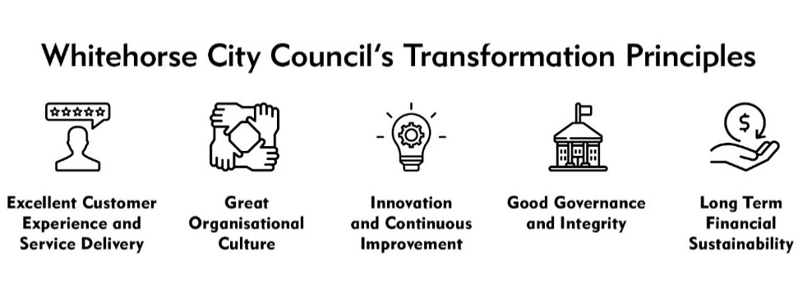

**CREATe - Our Values and Behaviours:**

Our shared values and behaviours are integral to how we go about our work, interact with each other and our community. Our employees ‘live’ these shared values. In living these values we also ensure that everyone has a voice and that everyone matters.

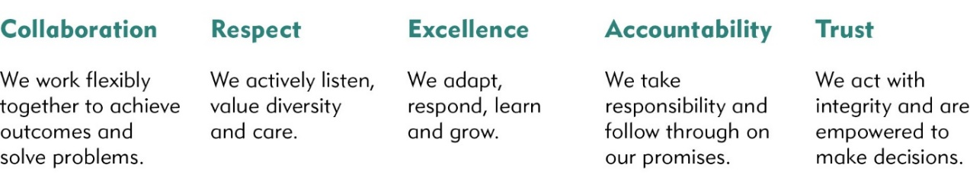

City of Whitehorse is a culturally and linguistically diverse community. We are proud of the diversity of our workforce and recognise the strength this provides in meeting the needs of our community. We are committed to upholding a safe, inclusive and respectful workplace that values the contribution of all.

Whitehorse City Council is committed to being a child safe organisation. We recognise our responsibilities to keep children and young people safe from harm and have established policies, procedures and training to achieve these commitments.

**Our Leaders:**

* Are results-focussed and driven towards the success of our community.
* Demonstrate a genuine interest in community, people and teams.
* Are brave enough to try new things and vulnerable enough maintain a growth mindset and are eager to learn.
* Encourage and demonstrate true cross-organisational collaboration.
* Are agile and lead the organisation through the principles of transformation, change and innovation.
* Are relationship builders. They take an engagement approach and help lead the way for all others to engage.
* They are trusted by our Community and our People.
* Make astute decisions that are future-focussed and maintain our long-term sustainability.

## **Goal Statement**

This position will lead the development and implementation of best practice, sustainable management practices and systems with respect to Council’s capital works program development and management, capital projects delivery, asset management strategy and facility maintenance.

Success in this role includes:

* The four year Capital Works Program is delivered on-time and within budget in a manner that is sustainable and value for money to the community.
* The public asset infrastructure within Council is designed, constructed and maintained for the benefit of the Whitehorse community.
* The newly integrated project delivery and assets team is cohesive and integrated, actively engaging with council and the community with exceptional customer service.
* Facilitate optimum life expectancy and maximum accessibility of all Council assets
* Implementation of an effective asset management program for the whole of life maintenance

## **Key Responsibilities**

#### Position Specific Responsibilities

* General
* Lead the Project Delivery and Assets Department to achieve an efficient and effective team and contribute to a positive workplace culture.
* Manage the successful financial performance of the Department and ensure the budget and rate of return targets are met and efficiency gains achieved through reform and innovation.
* Ensure the work practices and culture of the Project Delivery and Assets Department embrace and encourage adherence to relevant OHS and EO legislation and policies.

#### Capital Works Program

In partnership with the Finance Department, lead, develop and facilitate:

* The draft four year Capital Works Program for review and adoption by Council as part of the annual budget process
* Council’s 10-year Capital Works Program as part of the annual budget development process.
* Robust monitoring and reporting systems to ensure projects are delivered on time, within budget and in accordance with quality expectations. This is to include quarterly forecasting for projected annual capital works expenditure, timely project capitalisation and work-in-progress management.
* Regular performance status reports to EMT and Council.
* Develop, update and facilitate for delivery to Finance
* Appropriate procedures and relevant activities to verify physical assets and impairment where necessary.
* Employee cost recharge calculations for all capital projects.

Support Finance with regards to:-

* Policy, accounting, reconciliation and audits on all capital works activity whilst undertaking the necessary validation, testing, organisational co-ordination and data compilation to execute these activities.
* Balance sheet reconciliations and statutory reporting.
* Provision of advice and financial support particularly forecasting and budgeting for Capital Works Project Managers.
* Capital Program Management
* Develop strong and effective partnerships with internal and external stakeholders in the planning, design and delivery of Council’s Capital Works Program.
* Assist and support key internal and external stakeholders in the planning and delivery of capital works projects.
* Continually review the Corporate Asset Risk Register to identify potential risk factors as they apply to the general delivery of capital projects and then, in liaison with relevant Department and Project Managers, take effective action to minimise and effectively manage those risks.
* Lead, facilitate and support the development and ongoing operation of a cross-functional Capital Works Steering Committee as part of Council’s integrated approach to Asset Management.
* Establish and support uniform processes to improve organisational competence with business case and project management practices.
* Capital Projects Delivery
* Manage the delivery of capital projects including concept development, preparation of design and tender documentation, tender evaluation, construction supervision, contract administration and handover at project completion.
* Identify risks and threats and assist in devising strategies to mitigate these risks from concept; with an emphasis on championing the development, implantation and management of risk.
* Establish and maintain effective working relationships with key internal and external stakeholders, throughout project delivery, including appropriate consultation on design functionality, facility operation and transition issues to ensure appropriate and balanced input to development of customer services.
* Devise, implement and report to an agreed framework on project status to departmental management and steering committees, including recommending necessary project delivery strategies and providing high quality advice on project delivery matters.
* Utilise methodologies and practices that support planning, management and review of projects through their lifecycle.
* Effectively plan, manage and review performance of resources to identify opportunities for improved productivity and redirection of resources to ensure the effective delivery of projects and services.
* Develop both specialist and cross-functional teams fostering team work and innovative thinking.
* Provide timely and expert / technical project management advice to Councillors, the EMT and the broader organisation.

#### Asset Management Strategy:

* Lead the development and implementation of sustainable asset management policies, systems and practices to facilitate optimum life expectancy, maximum accessibility and the achievement of affordable levels of service for Council’s assets and infrastructure.
* Coordinate and project manage the continued implementation of Council’s integrated asset management system (WAMS) to meet the Executive Management Team’s (EMT) agreed project milestones.
* Establish training programs and administrative controls to promote widespread use of the asset management system across the organisation.
* Establish protocols and business rules for the capture, cleansing and verification of data for use in WAMS and Council’s GIS System.
* Assume the role of Chair of Council’s Asset Management Steering Committee (AMSC) and lead the AMSC in its role of implementing Asset Management Policy and Asset Management Strategy direction and initiatives.

#### Facility Maintenance

* Oversee the ongoing implementation of an effective asset management program for the whole of life maintenance, timely renewal of existing and the provision of new assets as part of Council’s 10 year Capital Works Program.
* Ensure adequate systems and controls are established and enforced to minimise risk and maximise occupational health and safety of all stakeholders associated with maintenance and renewal works.
* Ensure the programmed, preventative and reactive maintenance programs are adequately funded and resourced so that Council’s building assets are, as far as is practical, fit for purpose to facilitate the delivery of services to the Whitehorse community.
* Continue to develop facilities maintenance practices that ensure Council is meeting its regulatory requirements.
* Ensure Council continues in implementing best practice facilities maintenance standards.

*Corporate Responsibilities*

As a member of the Infrastructure Management Team, the Manager Project Delivery & Assets will:

* Ensure adherence to all Corporate Policies, Procedures and the Organisational Goals and Values in the current Whitehorse City Council Collective Agreement by all departmental staff.
* Ensure the organisation is aware of and compliant with relevant statutes and legislation.
* Identify and recommend changes to policy and procedure in areas of responsibility.
* Ensure that risk management principles are adopted in all decision-making processes within the department.
* Ensure the ongoing identification, reporting and resolution of risk management activities (including that staff are appropriately trained) and ensure that all relevant operating procedures provide for a safe working environment.
* Apply sound financial management techniques to departmental budget processes.
* Provide equitable and sound management to staff, (including ensuring appropriate training, development and motivation) to ensure that departmental KRA’s are met and to address the strategic objectives of the department.
* Ensure appropriate care and use of assets and equipment.
* Ensure collaboration and input from all relevant Directorates and staff to deliver effective and efficient services to the community.

### **Authority**

*Budget:* The position is directly responsible for a recurrent operational budget in the order of $ Million,

a capital budget of $41 million and the maintenance oversight of approx. 360 buildings on Council land, with a replacement value in excess of $300 Million.

The position is also responsible for the development, reporting and management oversight of Council’s annual Capital   
 Works program of approximately $80 million as well as the ten year Capital Works Program.

*Staff Responsibility:*

The position is responsible for the management of a diverse team of 19 professional and technical officers reporting through 5 streams.

This position will positively influence and engage with employees and stakeholders to overall to improve organisational principles and embed a culture of robust change and continuous improvement.

*Decision Making:*

* The position is accountable for the effective and efficient performance of Council’s asset management, project management and facilities information systems.
* Under the general guidance of the Director, this position has authority and freedom to act within established operational and budgetary guidelines and the provision of relevant Acts, regulations, codes and City policies.
* The position is responsible with the development of policy recommendations for consideration by Council and EMT and reports given to Senior Council staff.
* The position will make decisions using established best practice project management techniques within the industry.

### **Key Relationships**

* This position reports to the Director Infrastructure and, as part of the senior management team, is expected to contribute to the overall successful performance of the Directorate.
* This position will liaise closely with EMT and Councillors to provide high level strategic and operational advice,
* This role will develop relationships with all employees to influence the adoption of best practice and collaboration across the organisation.
* Where appropriate this role may also liaise with advisory committees, other municipalities industry bodies, government departments, members of the community and other stakeholders to deliver set organisational goals.

**Selection Criteria**

##### Qualifications and experience

* Tertiary Qualifications in Civil Engineering, Project Management and/or Architecture or other field directly related to project management and infrastructure management.
* Extensive experience in the development and overall program oversight of a diverse range of civil works, building and open space or similar projects. Local Government experience would be an advantage.
* Understanding of the economic, political, social issues relating to governance, corporate administration and civic relations in a Local Government environment.

*Technology*

* Extensive knowledge and experience in the application of software programs which can be used to improve work practices.
* High level skills in MS Office Suite.
* Extensive knowledge and experience in the application of financial and project management software programs, including the ability to monitor and control projects and budgets through use of computer applications.

*Other technical skills*

* Substantial knowledge of commercial and business principles and commitment to high quality and sustainable service.
* Ability to formulate and manage both high level strategic plans and associated operational budgets.
* Demonstrated capacity to ensure that service units are efficient, collaborative, operating within the principles of best practice and are customer driven
* Ability to manage own time, set priorities, and achieve targets in the completion of a diverse range of activities and complete projects and budgets on time.
* Excellent project management skills and an understanding of local government financial accountability and auditing requirements.
* Understanding and experience in asset management and life cycle approach to facility maintenance.
* Understanding of the National Competition Policy and State Government “Best Value” legislation contained within the Local Government Act 1989.
* Demonstrated understanding of asset management principles and their application to delivery of capital works investment.
* Experience in the preparation, procurement and assessment of tenders for a diverse range of capital works and maintenance services contracts.
* Ability to formulate and manage an operations budget.
* Ability to manage own time, set priorities, and achieve targets in the completion of a diverse range of activities and complete projects and budgets on time.

*Interpersonal*

* Demonstrated exceptional skills to lead motivate and develop employees in the pursuit of organisational goals.
* Excellent written and verbal communication skills with the ability to produce high quality reports and discussion papers, make formal presentations and to represent Council in professional, organisational & community forums.
* Excellent negotiation, influence and persuasion skills with the ability to use discretion and judgment in a complex business and political environment, the ability to manage the conflicting requirements of different stakeholders to produce positive outcomes, and provide astute, confidential and diplomatic specialist advice.
* Ability to influence and embed an organisational culture that continuously strives to improve by encouraging, valuing, listening and acting on customer feedback.

*Leadership/management:*

* A collaborative professional leader demonstrating positive work behaviours with a genuine commitment to embedding the organisation’s values within teams, including a high level of emotional intelligence, critical self-awareness and sound judgment.
* A relationship builder who strives to develop and maintain positive relationships within a political environment.
* A record of achievement and excellence at a senior level of people leadership in a diverse, complex and political environment across a range of portfolios. Supported by demonstrated experience in leading and managing multifaceted teams, particularly through periods of change.
* A team player with outstanding stakeholder management skills, astute commercial experience.
* A strong lateral, conceptual, analytical and strategic thinker with excellent problem solving and decision making abilities.
* A demonstrated ability to consider multiple perspectives and consider complex information within a multifaceted and complex changing environment, to create viable options, strategic direction, programs, and plans to address organisational objectives and inspire a clear sense of purpose and direction.
* Demonstrated ability to lead, develop and motivate employees and contribute to the development of long term resource planning.
* Demonstrated political astuteness including the ability gauge the various and differing opinions of the Councillor group and work collaboratively to achieve the organisational objectives.

**Other Attributes (Desirable)**

* Understanding of, or the ability to obtain knowledge, of the diversity of working with Councillors and local government frameworks

**Notes and comments:**

* A current Driver’s Licence is required for this role.
* A successful National Police check may be required.
* A successful Working with Children’s Check may be required.
* The position includes inherent physical requirements. Please refer to the Physical and Functional Requirements Checklist for more information. Short listed candidates may be required to attend a pre-employment medical examination.
* The position may be required to attend out of hours meeting.
* The position may be required to work from different locations within the municipality.

|  |  |  |  |
| --- | --- | --- | --- |
| **EMPLOYEE NAME:** |  | | |
| **Employee Signature:** |  | **Date:** |  |

PHYSICAL REQUIREMENTS FOR POSITION



POSITION TITLE: Manager Project Delivery and Assets

LOCATION/DEPARTMENT: Assets, Buildings and Capital Works

TASK DESCRIPTIONS (Tick relevant frequency)

|  |  |  |  |
| --- | --- | --- | --- |
| Task | Performed Often | Performed Sometimes | Never/Rarely Performed |
| Keyboard duties | ✓ |  |  |
| Reading tasks | ✓ |  |  |
| Writing tasks | ✓ |  |  |
| Sitting (extended periods) | ✓ |  |  |
| Walking/standing (briefly) | ✓ |  |  |
| Walking/standing (extended) |  |  | ✓ |
| Driving car/utility/truck |  |  | ✓ |
| Lifting/carrying duties (light) |  | ✓ |  |
| Lifting/carrying duties (heavy) |  |  | ✓ |
| Pushing/pulling tasks (light) |  |  | ✓ |
| Pushing/pulling tasks (heavy) |  |  | ✓ |
| Chopping/digging tasks |  |  | ✓ |
| Bending/kneeling requirements |  |  | ✓ |
| Climbing stairs/ladders/scaffolds |  |  | ✓ |
| Handling grease/oils |  |  | ✓ |
| Exposure to dust/dirt |  |  | ✓ |
| Exposure to hazardous materials |  |  | ✓ |
| Exposure to noise |  |  | ✓ |
| Repetitive arm/wrist/hand movements | ✓ |  |  |
| Other (please specify) |  |  |  |