Job title: Manager Community Engagement and Development
Classification: Senior Officer | Effective Date: November 2023
Reports to: Director Community Services | Tenure: Maximum Term Contract

About Us:
At Whitehorse City Council, community is at the heart of everything we do.
We aspire to be a healthy, vibrant, prosperous, and sustainable community. We enable this through strong leadership and community partnerships.
We strive to stay ahead of evolving changes and needs of our community.
Our five key principles empower our employees to be innovative and provide an excellent customer experience. We are a resilient organisation where everyone belongs.
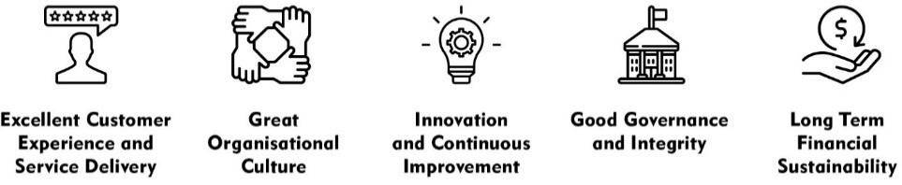

CREATe - Our Values and Behaviours:
Our shared values and behaviours are integral to how we go about our work, interact with each other and our community. Our employees ‘live’ these shared values. In living these values, we also ensure that everyone has a voice and that everyone matters.
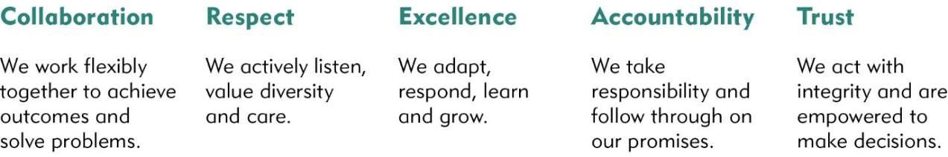

The City of Whitehorse is a culturally and linguistically diverse community. We are proud of the diversity of our workforce and recognise the strength this provides in meeting the needs of our community. We are committed to upholding a safe, inclusive, and respectful workplace that values the contribution of all.
Whitehorse City Council is committed to being a child-safe organisation. We recognise our responsibility to keep children and young people safe from harm and have established policies, procedures, and training to achieve these commitments.

Goal Statement
This position provides leadership, strategic direction, and overall management of the Community Engagement and Development Department that enables the achievement of organisational strategic and operational objectives.

Reporting to the Director Community Services, this role manages key internal and external relationships to build sustainable improvements to the quality of life of the community.
.

Key Responsibilities
Position Specific Responsibilities
Lead, manage and coordinate the effective delivery of:

- Community Engagement
  - Developing, implementing, and leading Community Engagement policies and processes.
  - Providing leadership and capacity building across the organisation to ensure effective community engagement is undertaken to inform decision making and to meet compliance obligations.

- Community Development
  - Developing, leading, and facilitating a wide range of services, programs and initiatives that drive community outcomes in the areas of health, wellbeing, community strengthening, connection and capacity building.

- Strategic Corporate Planning
  - Contribute to the development and implementation of Council’s strategic corporate planning framework with a particular focus on the Health and Wellbeing Plan.
  - Lead performance reporting and monitoring for areas of responsibility.

- Other focus areas that contribute to enhanced community outcomes to be determined following the finalisation of an internal structure review.

- Provide and coordinate advice to Council, Chief Executive Officer, the Executive, management, and the organisation on portfolio related issues.

- Provide ongoing leadership, advice, and support where appropriate to build the competence and confidence of the organisation in the areas of community development, community engagement and other areas of responsibility as required.

- Preparation, monitoring and reporting of the Departmental plan and budget.

Corporate Responsibilities
- Ensure adherence to all Corporate Policies, Procedures and the Organisational Goals and Values Principles in the current Whitehorse City Council Collective Agreement by all staff under supervision.
- Ensure the organisation is aware of and compliant with relevant statutes and legislation.
- Review and maintain current and relevant policy and procedure in areas of responsibility.
- Embed risk management principles in all decision-making processes within the department.
- Undertake identification, reporting and resolution of risk management activities (including appropriate staff training) and ensure that all relevant operating procedures provide for a safe working environment.
- Apply sound fiscal management techniques to team budget processes.
- Provide equitable and sound supervision of staff, (including ensuring appropriate training, development, and motivation) to ensure that team KRA’s are met and contribute to the strategic objectives of the organisation.
- Ensure appropriate care and use of assets and equipment.

Accountability and Extent of Authority
Budget: The position is responsible for interpreting and applying understanding of key financial indicators and the wider environment to make better decisions and on a day-to-day basis for the departmental budget.
Staff responsibility: The position is responsible for the management and leadership of a team to achieve high performance outcomes, developing team capabilities, team cohesion and the ability to effectively manage conflict and under performance.

Judgement and Decision Making
- Decisions made by the position have a significant effect on the Department and the organisation.
- Ability to think, analyse, assess options and consider broader and horizonal context to develop practical solutions.

Specialist Knowledge and Skills

Sound understanding of the community services sector including roles of levels of government, not-for-profits, and community groups.

Ability to advise on and lead sensitive human centric and social issues and matters that are important to Council staff and the community

Produce high quality reports and discussion papers, make persuasive formal presentations, and represent Council in professional, organisational and community forums.

Ability to sensitively navigate, inform and manage complex social policy matters.

Consider multiple perspectives and complex information within a multifaceted and complex changing environment, to create viable options.

Qualifications and Experience

- Relevant tertiary qualification and experience managing people.
- Experience and/or knowledge of how people go through change, the change process and how to lead through change.
- Acute business acumen and understanding of organisational issues and challenges, particularly as they may present in a Local Government organisation.
- Working with Children Check.

Interpersonal Skills
- Ability to promote the Council vision, direction, and goals to employees.
- Excellent verbal, presentation, and written communication skills to enable effective communication with all levels of management, employees, and external contacts.
- Well-developed negotiation, problem-solving and persuasion skills with the ability to use discretion and judgement and develop and maintain professional relationships in a political environment.
- Ability to lead, motivate and develop employees. Creating a strong sense of purpose aligned with strategic direction.
- Values driven demonstrating emotional intelligence and integrity.

Key Relationships:
- The incumbent consults with the Chief Executive Officer, and Executive Leadership Team to provide advice on matters relating to community development and engagement and other areas of responsibility.
- The incumbent is part of the Senior Leadership Team (SLT) and must foster strong collaborative working relationships.
- Negotiate and maintain a professional relationship with other community and health organisations, other levels of Government, peak organisations, relevant private sector agencies and appropriate local organisations.

Management Skills
- Ability to articulate, lead and model a positive culture and organisational values.
- Analytical and lateral thinking skills and the ability to take the initiative, drive change and implement innovations.
- Ability to initiate, support and champion change and encourage other to challenge the status quo and actively seek opportunities to improve.
- Demonstrated ability to develop, manage and maintain business plans and associated budgetary and financial management requirements.
- Evidence of strong leadership and motivational abilities in a diverse, fast changing, complex environment.

- The ability to provide leadership and guidance to staff under supervision and to develop and monitor performance objectives for staff.
- Values driven demonstrating high levels of emotional intelligence and integrity and demonstrated ability to act as a stabilising influence in emotionally charged situations.
- Lead, develop and motivate others within the department and across the organisation inspiring direction and purpose through alignment with Council strategic direction applying a high level of emotional intelligence, critical self-awareness, and sound judgement.
- Use technology and information to maximise efficiency and effectiveness.
- Embeds best practice governance, risk and compliance ensuring Council operates within legislative and regulatory standards in line with Council’s risk appetite.

Key Selection Criteria
- Significant and successful demonstrated experience in the leadership, management, and delivery of a range of human services.
- Demonstrated ability to implement efficient, effective, and sustainable business practices through a continuous improvement lens.
- Excellent verbal, presentation, and written- including report writing communication skills to enable effective communication with all levels of Council, Executive, management, employees, and external partners and stakeholders.
- Proven ability to engage and motivate staff, develop capability and potential in others.
- Ability to sensitively navigate, inform and manage complex social policy matters.
- Values driven demonstrating high emotional intelligence and integrity.

CRE
Community is at the heart of everything we do.

Physical Requirements

Physical Functional Demand | Specific Physical Job Tasks | Frequency/Duration of performance of task per day | Comments
Kneeling/Squatting  Tasks involve flexion/bending at the knees, ankle, and waist to work at low levels. | NIL
Hand/Arm Movement  Tasks involve use of hand/arms | NIL
Bending/Twisting  Tasks involve forward or backward bending or twisting at the waist. | NIL
Standing  Tasks involve standing in an upright position | NIL
Reaching  Tasks involve reaching above head, and above and equal to shoulder height | NIL
Walking  Tasks involve walking on slopes and walking whilst pushing/pulling objects | NIL
Lifting/Carrying  Tasks involve raising, lowering, and moving objects from one level position to another | NIL
Pushing/Pulling  Tasks involve pushing/pulling away, from and towards the body | NIL
Keyboard Duties  Tasks involve sitting at workstation and using computer. | No | Daily keyboard duties
Satisfactory Vision  Standard of vision required equal to that required for driver’s licence | NIL

