|  |  |
| --- | --- |
| **Job Description:** Gym Instructor | |
| **Classification**: Band 2 (no annualised) | **Effective Date**: October 2024 |
| **Reports to**: Gym Team Leader (AQBH)  Health & Fitness Coordinator (AQN) | **Tenure**: Permanent/Temporary/Casual |

# About Us:

At Whitehorse City Council, community is at the heart of everything we do.

We aspire to be a healthy, vibrant, prosperous and sustainable community. We enable this through strong leadership and community partnerships.

We strive to stay ahead of evolving changes and needs of our community.

Our five key principles empower our employees to be innovative and provide an excellent customer experience. We are a resilient organisation where everyone belongs.

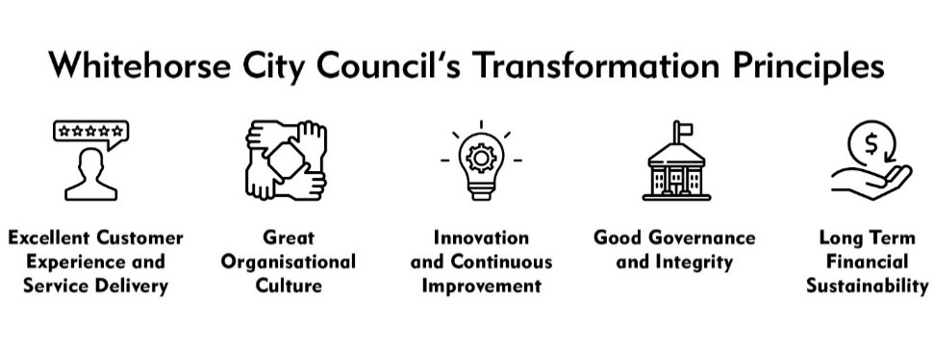

# CREATe - Our Values and Behaviours:

Our shared values and behaviours are integral to how we go about our work, interact with each other and our community. Our employees ‘live’ these shared values. In living these values we also ensure that everyone has a voice and that everyone matters.

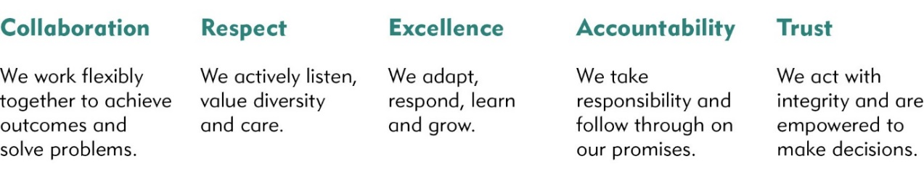

City of Whitehorse is a culturally and linguistically diverse community. We are proud of the diversity of our workforce and recognise the strength this provides in meeting the needs of our community. We are committed to upholding a safe, inclusive and respectful workplace that values the contribution of all.

Whitehorse City Council is committed to being a child safe organisation. We recognise our responsibilities to keep children and young people safe from harm and have established policies, procedures and training to achieve these commitments.

# Goal Statement

The position will provide a high level of customer service and fitness instruction in a safe and hygienic environment and in accordance with industry standards, to assist in the improvement of patron’s health and wellbeing.

# Key Responsibilities

## Position Specific Responsibilities

* Supervise patrons in the gym and advise and demonstrate safe and correct exercise methods and techniques.
* Provide high quality customer service in accordance with Centre policies.
* Conduct patron assessments, write programs and provide ongoing support in accordance with industry standards and Centre procedures.
* Accurately document and file patron programs and health information in accordance with Centre procedures.
* Positively promote the Centre and its programs.
* Treat all patron information in accordance with the Privacy Act.
* Conduct routine cleaning and maintenance tasks to ensure the gym area is clean and maintained to a high standard.
* Ensure the safety of patrons and respond to first aid and emergency situations in accordance with Centre procedures.
* Contribute ideas on area programs and service improvements.
* Act as Area Warden in emergency evacuations as required.

## Corporate Responsibilities

* Adhere to all Corporate Policies, Procedures and the Organisational Goals and Values in the current Whitehorse City Council Collective Agreement.
* Understand and adhere to the Risk Management Policy (as it relates to the employees work area) and related procedures that are designed to minimise injury and/or loss to individuals, assets and equipment.
* Report any matters that may impact on the safety of Council employees or citizens, assets and equipment.

# Accountability and Extent of Authority

**Budget:** Nil.

**Staff responsibility:** Nil.

**Judgement and Decision Making**

* The position has the authority to act within clearly documented operational guidelines. Any issues that arise that are outside the ordinary day to day responsibilities of the position are referred to the shift supervisor.

**Qualifications and Experience**

*Qualifications/ Certificates /Licences:*

* Certificate IV in Fitness or Bachelor Degree in Exercise and Sports Science/Human Movement
* AUSActive Registration or Exercise & Sport Science Australia (ESSA) Accreditation or equivalent accreditation.
* HLTAID011- Level 2 First Aid Certificate.
* HLTAID009 - CPR Qualification.
* Satisfactory National Criminal History Check.
* Employee Working with Childrens Check

*Technology:*

Basic skills in data entry.

Ability to use Microsoft Office applications including Outlook.

Basic skills to utlise gym consultation and program applications

*Other technical skills:*

Good customer service skills.

Ability to demonstrate and coach patrons on safe exercise methods and techniques.

**Interpersonal Skills**

* Good oral and written communication skills to enable positive interaction with patrons and other employees.
* Appreciation of the different needs of individuals and the ability to convey tolerance and sensitivity to patron’s values and beliefs.
* Friendly, enthusiastic and professional approach.

# *Key Relationships:*

* The position will liaise with other team members, senior staff, patrons, suppliers and peak industry bodies/consultants.

**Management Skills**

* Ability to work as part of a team and individually under routine supervision.
* Ability to provide on the job training based on skills and experience.

**Application Requirements**

* Satisfactory National (and International as applicable) Criminal History Check.
* Working with Children Check.

# Key Selection Criteria

1. Required current qualifications/certificates under “selection criteria essential – qualifications and experience”.
2. Ability to demonstrate and coach patrons on safe exercise methods and techniques.
3. Good oral and written communication skills to enable positive interaction with patrons and other employees.
4. Friendly, enthusiastic and professional approach.

# Physical Requirements

| Physical Functional Demand | Specific Physical Job Tasks | Frequency/Duration of performance of task per day | *Comments* |
| --- | --- | --- | --- |
| Kneeling/Squatting  Tasks involve flexion/bending at the knees, ankle, and waist in order to work at low levels. | ✓ | 5+ times a shift |  |
| Hand/Arm Movement  Tasks involve use of hand/arms | ✓ | 5+ times a shift |  |
| Bending/Twisting  Tasks involve forward or backward bending or twisting at the waist. | ✓ | 5+ times a shift |  |
| Standing  Tasks involve standing in an upright position | **✓** | 5+ times a shift |  |
| Reaching  Tasks involve reaching above head, and above and equal to shoulder height | **✓** | 2-4 times a shift |  |
| Walking  Tasks involve walking on slopes and walking whilst pushing/pulling objects | **✓** | 2-4 times a shift |  |
| Lifting/Carrying  Tasks involve raising, lowering and moving objects from one level position to another | **✓** | 2-4 times a shift |  |
| Pushing/Pulling  Tasks involve pushing/pulling away, from and towards the body | **✓** | 2-4 times a shift |  |
| **Keyboard Duties**  Tasks involve sitting at workstation and using computer. | **✓** | 5+ times a shift |  |
| **Satisfactory Vision**  Standard of vision required equal to that required for driver’s licence |  |  |  |

Any other relevant comments: