APPLICATION FOR A RESIDENTIAL PARKING PERMIT – 2024/25
You can now pay and apply for this permit online – visit www.whitehorse.vic.gov.au

Applicant Details
Applicant’s Name
Property Address
Phone (mobile) |  | Phone (b/hours)
Email address
Documentation to be attached with this application form
In order for this application to be considered you are required to provide copies of the following documents:
- Proof of residency such as a driver’s license, utility bill, residential lease or REIV bond lodgement etc.
Types of Permits | - An adhesive windscreen sticker that is linked to a specific vehicle’s registration  - A Visitor permit that can be hung from the rear vision mirror and transferred between vehicles visiting the property

Maximum Permit Allocations | Dwellings per Lot | Maximum Number of Permits
 | One dwelling | 3 permits
 | Two to three dwellings | 2 permits per dwelling
 | Four to fifteen dwellings | 1 permit per dwelling
 | More than 15 dwellings | No permits allocated
Number and Cost of Permits
 | Permit 1 (FREE) |  | Permit 2 ($66.00) |  | Permit 3 ($192.00)
Vehicle Details | Adhesive Permit | Visitor Permit | Adhesive Permit | Visitor Permit | Adhesive Permit | Visitor Permit
Registration
Car Make
Car Model
COMBINED COST | ONE PERMIT | FREE | TWO PERMITS | $66.00 | THREE PERMITS | $192.00

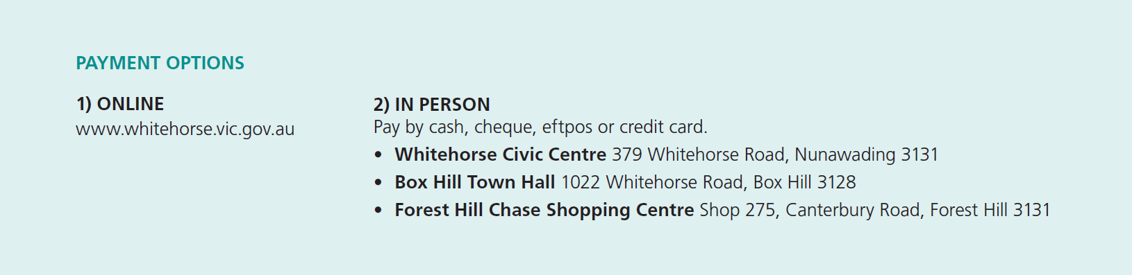
Signature: ________________________________________ Date: _______________________________________
The personal information on this form is being collected by Council to enable the processing of this application and for the purpose of administration of relevant Acts, Regulations and Local Laws. The personal information will be used by Council for that primary purpose or directly related purposes only. The information will not be released unless required by law. The applicant may apply to Council for access and/or amendments of the information.

Permit Conditions | - The applicant must supply valid copies of the required documentation  - The permit is only valid at the nominated site location stated on the permit  - The permit is only valid for 12 months  This permit is valid when  - Used by a resident permit holder or their visitors within the residential area of the address the permit is issued  - The permissive parking restriction allows parking for at least 30 minutes or more in a permit zone  - A vehicle specific or Visitors Parking Permit is securely displayed face up on the passenger side of the front windscreen so all details remain clearly visible from outside the vehicle.  - Used in a designated time restricted residential parking zones only  - The annual permit fee is paid  This permit is not valid when  - Used in areas outside the area designated on the permit  - Used in no stopping areas, clearways, bus zones, off-street car parks or similar  - Vehicles are parked over driveways or on footpaths, nature strips or medium strips or parked in non-residential areas including commercial, industrial or mixed-use areas or off-street car parks  - Used after the expiry date  - Used for vehicle with a Payload of 1500kgs or more, or for heavy vehicles, motorhomes, caravans, boats, machinery or equipments, trailers or any vehicle or machinery that is designed or modified to be towed by another vehicle  • Permits are not transferable and are only to be used by bona fide residents and visitors  • Permits are not to be leased, rented out, sold or given away  • Permits are not to be copied and the copies then used in other vehicles  • No form of advertising of a permit for rent, lease, sale, profit or other beneficial or fraudulent consideration, or causing such an advertisement to be published is permitted  • The issue of a permit does not guarantee the availability of a parking space  • The use of parking spaces may be suspended by members of the Victorian Police or by authorised Council Officers  • Visitor permits should be issued to the visitor on arrival and returned to the householder at the end of the visit  • Visitor residential parking permits are only valid when a visit to the residence is taking place.  Please Note: Any breach of the conditions may result in the cancellation of permits.
Breach of Permit Conditions | - The permit may be cancelled  - Fines may be issued  - Costs incurred by Council may be charged directly to the permit holder  - Goods or equipment may be impounded  - Future permit applications may be declined  - No refunds will be given where a permit is cancelled due to breach of its conditions.
Council Considerations | In deciding whether to grant a permit the Council will take into consideration:  - Details supplied by the permit applicant  - The suitability of the supporting documentation for this application  - The applicant’s record in applying for similar permits and adherence to permit conditions  - The effect on the quiet enjoyment of other users of the municipal place or road and the amenity of the area  - Whether any undue obstruction will be caused to pedestrians or vehicle traffic in the area specified
How to submit your application? | - Via email by sending to: customer.service@whitehorse.vic.gov.au  - Via mail by sending to:  Community Safety, Whitehorse City Council, Locked Bag 2, Nunawading Delivery Centre, VIC 3110  - In person at one of the Whitehorse City Council Customer Service Centres (refer to Payment Options)
How long before you receive a response? | - Allow 10 business days  Note: The permit process may be delayed if the required documentation is not provided, is out of date or insufficient.
Unsuccessful applications | - You will be notified in writing and any permit application fee will be refunded
Link to further information | https://www.whitehorse.vic.gov.au/residential-parking-permits

