APPLICATION FOR FOOTPATH TRADING
Excluding Box Hill Mall - 2021/2022
You can now pay and apply for this permit online – visit www.whitehorse.vic.gov.au

Business Details
Business Name
Business
Postal Address
Business Email
Contact Person Name
Phone (mobile) |  | Phone (b/hours)

Documentation to be attached with the application form
In order for this application to be considered you are required to provide copies of the following documents:
- Current Certificate of Liability for a minimum of 10 million dollars (AU$10,000,000) cover held by the business – Obtain from insurer

Options Available (Please specify numbers)
 | Barriers or Planter Boxes |  | A-frame Display Boards |  | Goods on Display
 | Tables, Chairs or Umbrella |  | Other (Please specify)

Annual Permit Cost
One selection $155.00 | Two selections $275.00
Three selections $390.00 | Four selections $500.00
Five selections $600.00
NOTE: All permits have an expiry date of 1 September – A pro rata fee of 50% apply to all new applications received after 1 March.

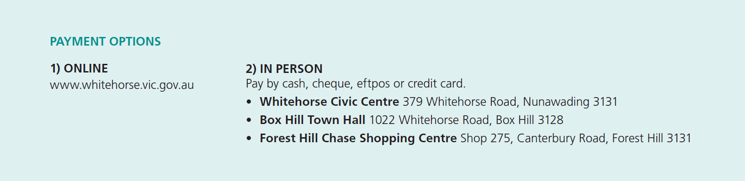

Signature: ________________________________________ Date: _______________________________________
The personal information collected is required for processing your Local Laws permit in accordance with the Road Management Act 2004 and Community Local Law 2014, managing the administration of your Local Laws permit and for any later renewal. Intended recipients of the information are authorised Council officers. Without consent your application may not be processed online. The information will remain for Council use only and not be disclosed except as required by law or if consent is provided to do so. You may view Council’s Privacy Policy online and access your information by contacting Compliance Department on 9262 6333.

Permit Conditions | - The permit fee must be paid before use  - The applicant must supply valid copies of the required documentation  - The permit is only valid at the nominated site location stated on the permit  - The permit is only valid for the time period stated on the permit  - The permit is not transferrable:  - Permits are not to be leased, sold or given away  - No form of advertising of a permit for rent, lease, sale profit or other beneficial or fraudulent consideration of causing such an advertisement to be published is permitted  - At the conclusion of the permit period a new application form must be submitted  - Permits are required for A-frame display boards, planter boxes, goods on display, tables, chairs, umbrellas and barriers or any other material  - Footpath trading furniture and fixtures must be of a high standard in terms of design, appearance and style as well as being deemed appropriate and sympathetic to the streetscape. All items must be sturdy, reliable and suitable for their intended use. All footpath trading furniture and fixtures must be approved by Council.  - Approved items such as café screens, retractable awnings and gas heaters attached to existing buildings or verandas must be capable of removal or relocation within 24 hours  - Council will NOT allow the installation of permanent structures, including electrical lighting and sound systems  - Permits are for a maximum period of 12 months  - Permits are subject to annual renewal and payment of a renewal fee set by Council  - Permit applications must meet the requirements of the general footpath trading guidelines (PDF 430.13KB) or specific footpath trading guidelines for Carrington Road, Box Hill (PDF 1.6MB)  - Permit holder must display permit sticker provided in the front of the building so it can be seen from the street  - Permits do not allow for exclusive use of an outdoor space and in some instances access may be required for a public event or permitted activity at Council’s discretion  - The permit may be suspended by a member of Victoria Police or by an authorised Council Officer for any reason at any time. No permit fee will be refunded
Breach of Permit Conditions | - The permit may be cancelled  - Fines may be issued  - Costs incurred by Council may be charged directly to the permit holder  - Goods or equipment may be impounded  - Future permit applications may be declined  - No refunds will be given where a permit is cancelled due to breach of its conditions.
How to submit your application? | - Via email by sending to: customer.service@whitehorse.vic.gov.au  - Via mail by sending to:  Community Laws, Whitehorse City Council, Locked Bag 2, Nunawading Delivery Centre, VIC 3110  - In person at one of the Whitehorse City Council Customer Service Centres (refer to Payment Options)
Council Considerations | In deciding whether to grant a permit the Council will take into consideration:  - Details supplied by the permit applicant  - The suitability of the supporting documentation for this application  - The applicant’s record in applying for similar permits and adherence to permit conditions  - The effect on the quiet enjoyment of other users of the municipal place or road and the amenity of the area  - Whether any undue obstruction will be caused to pedestrians or vehicle traffic in the area specified
How long before you receive a response? | - Allow 10 days to process your application  Note: The permit process may be delayed if the required documentation is not provided, is out of date or insufficient.
Unsuccessful applications | - You will be notified in writing and any permit application fee will be refunded
Link to further information | https://www.whitehorse.vic.gov.au/living-working/business/council-public-space/footpath-trading

