APPLICATION FOR CONSTRUCTION WORKERS PARKING PERMITS – 2021-2022

Applicant Details
Applicant’s Name
Company Name (if applicable)
Address
Phone (mobile) |  | Phone (b/hours)
Email Address

Documentation to be attached with this application form
In order for this application to be considered you are required to provide copies of the following documents:
- The building permit for the construction site.
- Plan of the site and parking area subject to the permit

Construction Site and Permit Period
Construction Site Address
Proposed Dates that Permit/s are Required | ____/____/____ to ____/____/____

Permit Numbers and Cost
Administration Fee |  | $ 95.00
Metered Parking Bays | $200.00 (per week) X_______ Permits X_____ Weeks | $
All Other Parking Bays | $42.50 (per week) X_______ Permits X_____ Weeks | $
TOTAL (Maximum of 4 bays allowed) |  | $

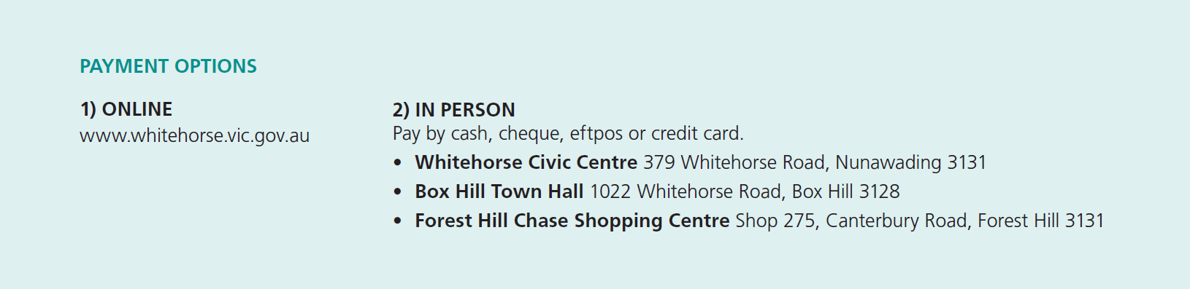

Signature: ________________________________________ Date: ______________________________________

Permit Conditions | - The permit fee must be paid before use  - The applicant must supply valid copies of the required documentation  - The permit is only valid at the nominated site location stated on the permit  - The permit is only valid for the time period stated on the permit  - The permit is not transferrable:  - Permits are not to be leased, sold or given away  - No form of advertising of a permit for rent, lease, sale profit or other beneficial or fraudulent consideration of causing such an advertisement to be published is permitted  - The permit must be securely displayed so all details remain clearly visible through the passenger side of the front windscreen throughout the duration of parking  - Permit holders must comply with Victorian Road Rules at all times  - Permits is only valid for nominated bays (usually outside construction sites)  - Permits are not valid in:  - Areas marked as no parking or no stopping including clearways during restriction times  - Permit restricted parking areas such as disabled persons’ parking areas, bus stops, taxi ranks, loading zones and construction zones  - Parking restriction areas of two minutes or less  - Prohibited areas such as across driveways, centre reservations, nature strips and footways  - Front of commercial, industrial or mixed-use areas  - A parking permit for a specific vehicle cannot be used in another vehicle  - Permits are not to be photocopied and the copies used in other vehicles  - The permit can only be used by vehicles that do not exceed 7.5 meters in length or 4.5 tonnes in gross weight  - Permits cannot be used for motor homes, caravans, boats or earthmoving machinery/equipment  - At the conclusion of the permit period a new application form must be submitted  - The permit may be suspended by a member of Victoria Police or by an authorised Council Officer for any reason at any time. No permit fee will be refunded  Note: Holding a permit does not ensure the availability of a parking space
Breach of Permit Conditions | - The permit may be cancelled  - Fines may be issued  - Costs incurred by Council may be charged directly to the permit holder  - Goods or equipment may be impounded  - Future permit applications may be declined
How to submit your application? | - Via email by sending to: LocalLaws.Admin@whitehorse.vic.gov.au  - Via mail by sending to:  Community Laws, Whitehorse City Council, Locked Bag 2, Nunawading Delivery Centre, VIC 3110  - In person at one of the Whitehorse City Council Customer Service Centres (refer to Payment Options)
Council Considerations | In deciding whether to grant a permit the Council will take into consideration:  - The nature, time, location and duration of the proposed construction  - Details supplied by the permit applicant  - The suitability of the supporting documentation for this application  - If the area is a commercial area  - Whether any undue obstruction will be caused to pedestrians or vehicle traffic in the area specified  - Whether any interference will be caused in relation to other approved activities in the area
How long before you receive a response? | - Allow 10 business days  Note: The permit process may be delayed if the required documentation is not provided, is out of date or insufficient.
Unsuccessful applications | - You will be notified in writing and any permit application fee will be refunded
Link to further information | https://www.whitehorse.vic.gov.au/living-working/parking/parking- permits/construction-workers-parking-permit

The personal information on this form is being collected by Council to enable the processing of this application and for the purpose of administration of relevant Acts, Regulations and Local Laws. The personal information will be used by Council for that primary purpose or directly related purposes only. The information will not be released unless required by law. The applicant may apply to Council for access and/or amendments of the information.

