Planning and Environment Act 1987

WHITEHORSE Planning Scheme

Amendment C256whse

Explanatory Report

Overview
The amendment rezones land at 110 Albion Road, Box Hill from Special Use Zone Schedule 1 (SUZ1) to General Residential Zone, Schedule 1 (GRZ1) and applies the Significant Landscape Overlay, Schedule 9 (SLO9) to the land.

Where you may inspect this amendment
The amendment can be inspected free of charge at the Whitehorse City Council website at www.whitehorse.vic.gov.au.
The amendment is available for public inspection, free of charge, during office hours at the following places:
- during office hours, at the office of the planning authority, Whitehorse City Council, Planning Counter, 379-397 Whitehorse Road, Nunawading.
- during business hours at the Whitehorse City Council Service Centres at Box Hill Town Hall (1022 Whitehorse Road, Box Hill).
- during business hours at libraries in the City of Whitehorse at Nunawading and Vermont South.
- at the Whitehorse City Council website, https://www.whitehorse.vic.gov.au/amendment-c256
The amendment can also be inspected free of charge at the Department of Transport and Planning website at planning.vic.gov.au/public-inspection or by contacting the office on 1800 789 386 to arrange a time to view the amendment documentation.

Submissions
Any person may make a submission to the planning authority about the amendment. Submissions about the amendment must be received by 5 March 2026.
A submission must be sent to:
Online: https://yoursay.whitehorse.vic.gov.au/amendment-c256
Mail: Strategic Planning Unit, Amendment C256
Whitehorse City Council
Locked Bag 2
Nunawading VIC 3131
Email: customer.service@whitehorse.vic.gov.au

Panel hearing dates
In accordance with clause 4(2) of Ministerial Direction No.15 the following panel hearing dates have been set for this amendment:
- Directions hearing: the week beginning 27 April 2026
- Panel hearing: the week beginning 08 June 2026

Details of the amendment

Who is the planning authority?
This amendment has been prepared by the Whitehorse City Council, which is the planning authority for this amendment.
The amendment has been made at the request of Human Habitats on behalf of Villa Maria Catholic Homes Ltd.

Land affected by the amendment
The amendment applies to land at 110 Albion Road, Box Hill, which is otherwise described as Lot 2 on LP201596. The amendment land is approximately 150 metres to the west of the junction Albion Road and Middleborough Road and 1 kilometre to the southeast of the Box Hill Metropolitan Activity Centre. It is irregular in shape with a frontage to Albion Road of approximately 72 metres and an area of approximately 5,050 sqm (refer Figure 1.).
The land falls approximately 8 metres from the northwest corner of the property to Gardiners Creek, which runs alongside the southeast boundary of the amendment land.
The land does not accommodate any buildings; however, remnants of asphalt from its previous use remain. The buildings that once stood on the land were demolished in 2019.
Vehicle access to the land is provided from Albion Road via a crossover adjacent to the northwest corner of the land.
The amendment land contains 119 trees, of which 26 species are identified as native to Victoria. This vegetation is mainly located along the property boundaries, with some within the northern setback towards the frontage. A mapping reference table is included at Attachment 1 of this Explanatory Report.
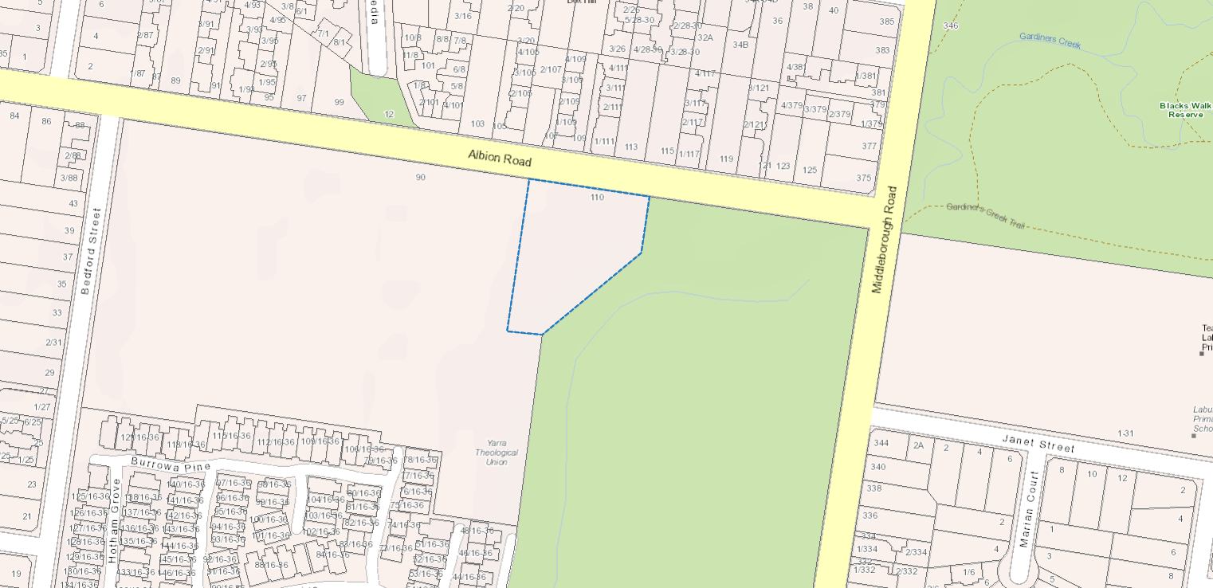
Figure 1: Amendment land (outlined in blue)
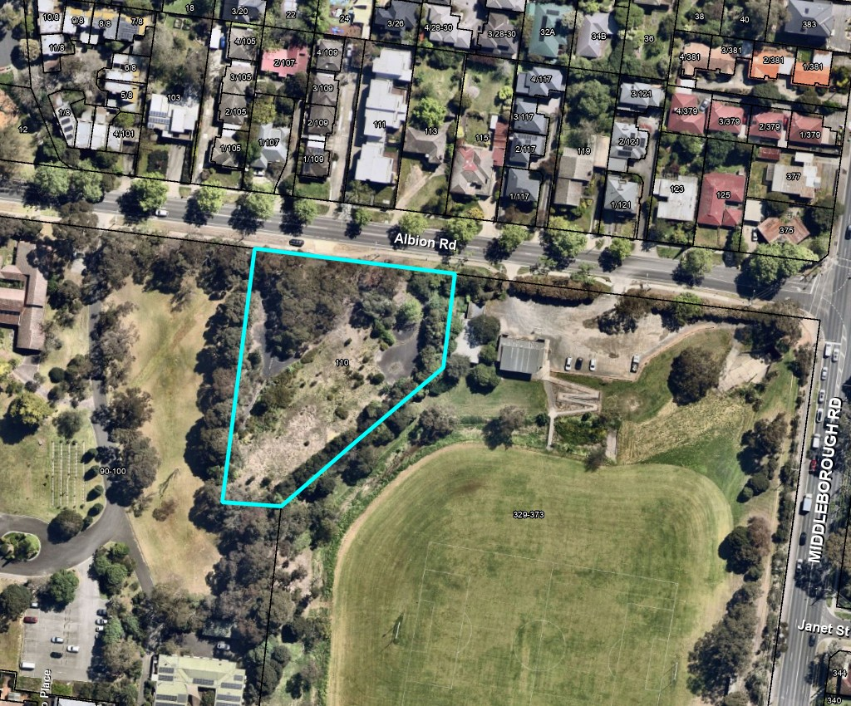
Figure 2: Aerial photograph of amendment land (outlined in blue)

What the amendment does
The amendment will facilitate the use and development of the land for residential and other appropriate purposes, while ensuring that development is compatible with the landscape character of the area.
Specifically, the amendment makes the following changes:
Zoning maps
- Amends Planning Scheme ZONES MAP No. 2 to rezone land at 110 Albion Road, Box Hill, from Special Use Zone, Schedule 1 (SUZ1) to General Residential Zone Schedule 1 (GRZ1).
Overlays maps
- Amends Planning Scheme SIGNIFICANT LANDSCAPE OVERLAY MAP No 2SLO to apply the Significant Landscape Overlay, Schedule 9 (SLO9) to 110 Albion Road, Box Hill
Planning scheme ordinance
- Amends Clause 02.04 (Strategic Framework Plans) to identify the land as a Natural Change Area in Plan 2: Housing Framework Plan.
- Amends the Neighbourhood Character Precincts Map at Clause 15.01-5L (Preferred neighbourhood character) to identify the character type of the land as Garden Suburban and include it in Precinct 10 (GS10).

Why is the amendment required?
Rezoning
The purpose of the current zoning of the amendment land (SUZ) is to provide for land in private ownership to be used for an education centre or place of worship. The amendment land is currently vacant and is not being used for either of the purposes specified in schedule 1 to the SUZ. It was previously owned by the adjoining landowners at 90 Albion Road, which abuts the western boundary of the amendment land. 90 Albion Road shares the same SUZ1 zoning as the amendment land and is developed and used as a university, consistent with the intent of the SUZ1.
Rezoning of the amendment land to GRZ1 will facilitate its use and development for residential and other compatible uses. The application of GRZ1 to the land would be consistent with the zoning of nearby properties on the north side of Albion Road and the broader surrounding area. Application of the GRZ1 will provide greater flexibility in terms of land use compared to the SUZ1 and will offer clearer guidance on built form outcomes.
Applying the significant landscape overlay
Application of the SLO9 to the amendment land will ensure that the landscape character of the area is maintained and enhanced by recognising the contribution that existing trees on the land make to the visual amenity and character of the neighbourhood. The overlay will provide an appropriate mechanism to manage existing trees on the land and ensure that future development responds sensitively to its landscape context.
Outcomes and benefits
The amendment represents an acceptable planning outcome as it will enable the development of underutilised urban land for housing within an established residential area, consistent with the objectives of State and Local Planning Policy for housing growth. It provides for new development that respects the established landscape and character values of the area.
The amendment will deliver a net community benefit by supporting increased housing supply and diversity in a location with good access to public transport, services and community infrastructure. The social and economic benefits arising from additional housing opportunities will outweigh any potential costs associated with the introduction of the new planning provisions. The amendment will therefore contribute positively to the long-term sustainability and liveability of the municipality.

How does the amendment implement the objectives of planning in Victoria?
Rezoning the land to GRZ1 facilitates the sustainable use of underutilised urban land for residential purposes, supports housing growth in a well-serviced location, and ensures that development is consistent with the character and amenity of the surrounding area. The application of the SLO9 will ensure that the established landscape character of the area is appropriately considered, contributing to a pleasant and environmentally responsive neighbourhood.
In accordance with Section 12(1)(a) of the Act, the amendment implements planning scheme provisions by appropriately applying the GRZ1 and SLO9 to the land. These provisions provide clear guidance for land use and built form outcomes, manage valued vegetation and ensure that future development is compatible with surrounding land uses. By doing so, the amendment promotes the orderly, sustainable, and coordinated development of the site in accordance with the overarching objectives of planning in Victoria.

How does the amendment address any environmental, social and economic effects?

The amendment adequately addresses the environmental, social, and economic effects in accordance with Sections 12(2)(b) and (c) of the Planning and Environment Act 1987.
Environmental effects

No environmental overlays currently apply to the land. The amendment will result in a net environmental benefit by introducing planning provisions to manage vegetation and landscape features through the application of the SLO9. The SLO9 will ensure that future development considers the contribution of existing trees to neighbourhood character and landscape values, thereby enhancing the environmental quality and visual amenity of the area.
Social effects

The site is located within a predominantly residential area. The amendment will provide a community benefit by facilitating the orderly and sustainable development of the land for residential purposes, consistent with the surrounding land use pattern. It introduces appropriate built form controls and ensures that future development is assessed against relevant planning considerations, including design, amenity and neighbourhood character. The amendment also introduces greater guidance for non-residential uses (such as education centres, childcare centres and offices), ensuring that such uses are compatible with the residential context.

The land is located within an area of Aboriginal cultural heritage sensitivity. The amendment will not impact the operation of the Aboriginal Cultural Heritage Regulations 2018. Future permit applications for the land will remain subject to a consideration of Aboriginal Cultural Heritage.
Economic effects

The amendment will generate positive economic outcomes by facilitating the orderly development of land for residential purposes, contributing to increased housing supply and diversity within an established, well-serviced urban area. The resulting housing opportunities will support local population growth and reinforce the ongoing economic vitality of the municipality.

Does the amendment address climate change?

The proposed amendment appropriately addresses climate change risks in accordance with Ministerial Direction 22 – Climate Change Consideration under Section 12A of the Planning and Environment Act 1987.
Minimising Greenhouse Gas Emissions (Direction 22 – Clause 5)

The amendment facilitates the rezoning of the subject site from Special Use Zone to General Residential Zone – Schedule 1 (GRZ1), enabling significant change and intensification of urban land use. This approach supports emissions reduction targets by:
- Prioritising infill development within an established urban area rather than greenfield expansion, consistent with Victoria’s Housing Statement target for 70% of new homes in established areas.
- Locating development in proximity to multiple public transport routes, safe walking and cycling networks, and key activity centres, thereby reducing reliance on private vehicles and supporting active transport.
- Providing opportunities for subdivision and built form with optimal solar orientation and access, enhancing energy efficiency and supporting renewable energy integration at a local scale.
- Leveraging existing infrastructure within Box Hill to accommodate residential growth without significant additional environmental impact.
Increasing Resilience to Climate Change Risks (Direction 22 – Clause 6)

The site is located within a low-risk environment (Clause 13.01-1S), outside bushfire-prone areas, flood or inundation overlays, erosion management overlays, and coastal hazard zones. Future development will:
- Avoid exposure to natural hazards and ensure design measures are proportionate and practical.
- Incorporate sustainable design principles to enhance resilience at both building and precinct scales, including passive design, water-sensitive urban design, and potential renewable energy systems.
- Maintain compatibility with existing infrastructure and urban character without unreasonable impact on residents, the natural environment, or emergency management considerations

Does the amendment address relevant bushfire risk?

The land is not located within a designated bushfire prone area and is not in an area subject to a Bushfire Management Overlay. The amendment will not increase the risk to life, property, community infrastructure, or the natural environment from bushfire.

Does the amendment comply with the requirements of any other Minister’s Direction applicable to the amendment?

The amendment complies with Ministerial Direction No. 11: (Strategic Assessment of Amendments) under section 12 of the Act. The amendment is consistent with this direction which ensures a comprehensive strategic evaluation of a planning scheme amendment and the outcomes it produces.

How does the amendment support or implement the Planning Policy Framework and any adopted State policy?
The amendment is consistent with the following clauses of the Planning Policy Framework and will assist in achieving objectives of the clauses:
Clause 11.01-1S – Settlement

The amendment is consistent with, and supports the implementation of, several key clauses of the Planning Policy Framework (PPF). It will assist in achieving State planning objectives by facilitating housing growth within an existing serviced urban area, thereby promoting sustainable development.
Clause 11.01-1R – Settlement – Metropolitan Melbourne
The amendment aligns with strategies that encourage housing growth within the Urban Growth Boundary and the creation of a consolidated, sustainable city. It supports compact urban form and efficient use of existing infrastructure and services.
Clause 11.02-1S – Supply of Urban Land
The amendment contributes to the objective of ensuring a sufficient supply of land for residential development. It enables the intensification of an established urban area that is free from environmental constraints or land capability issues, consistent with the strategies of this clause.
Clause 15.01-1S – Urban Design
Rezoning the land to the General Residential Zone (GRZ) introduces comprehensive planning provisions for residential development, including the application of residential development standards. This will ensure that future development contributes to safe, healthy, and functional urban environments that foster a sense of place and identity.
Clause 15.01-1R – Urban Design – Metropolitan Melbourne
The amendment supports the metropolitan strategies to create a distinctive and liveable city with high-quality design and amenity. The GRZ provisions will facilitate well-designed residential outcomes consistent with these objectives
Clause 16.01-1S – Housing Supply and Clause 16.01-1R – Housing Supply – Metropolitan Melbourne
The amendment supports these policies by facilitating the delivery of well-located, integrated, and diverse housing that meets community needs. It increases housing supply within an established area, advancing the vision for a city of 20-minute neighbourhoods with convenient access to services, jobs, and public transport.
Clause 16.01-2S – Housing Affordability
By enabling additional housing supply in an accessible location, the amendment contributes to improved housing affordability in line with the objectives of this policy.

Is the amendment consistent with the delivery of the relevant housing target set out in the Planning Policy Framework?
The amendment is consistent with the delivery of housing targets set out in the Planning Policy Framework (PPF) and supports the strategic objectives for housing growth within the City of Whitehorse and metropolitan Melbourne.
The amendment facilitates additional housing opportunities within an established urban area. This will contribute to the municipality’s capacity to meet identified housing demand and targets.
Consistent with Clause 11.02 (Managing Growth), the amendment directs residential development to a location that is already serviced by infrastructure, public transport, and community facilities. This supports the efficient use of existing urban land and infrastructure and aligns with State policy to consolidate growth within established areas, reducing pressure for outward expansion.
The proposal also gives effect to Clause 16.01-1S (Housing Supply) by increasing the supply of land available for residential development in a location where housing is encouraged. The site represents a logical opportunity for incremental infill development within the existing urban fabric, contributing to sufficient and realisable housing capacity to meet local and metropolitan housing targets.
The amendment supports the delivery of a diverse and sustainable housing mix, consistent with the objectives of the GRZ. It provides flexibility for a range of dwelling types and densities to accommodate different household sizes, life stages, and income levels. The site’s proximity to the Box Hill Metropolitan Activity Centre, employment opportunities, education, and public transport services makes it particularly suitable for residential development.

How does the amendment support or implement the Municipal Planning Strategy?
The amendment is consistent with, and supports the implementation of, the Municipal Planning Strategy (MPS) of the City of Whitehorse. It advances several strategic directions by applying appropriate planning provisions that respond to the site’s environmental, built form, and housing context, as outlined below.
- Environmental and Landscape Values (Clause 02.03-2)
The amendment supports this strategic direction through the application of the Significant Landscape Overlay to the site. This will ensure that future development recognises and responds to the valued landscape characteristics of the area, protecting the visual and environmental qualities that contribute to local character.
- Built Environment and Heritage (Clause 02.03-5)
By including the site within the Garden Suburban 10 precinct, the amendment reinforces the preferred neighbourhood character and built form outcomes sought for this area. The provisions will guide development to respect existing scale, spacing, and landscaping patterns, thereby maintaining the suburban garden setting that defines the municipality’s identity.
- Housing (Clause 02.03-6)
The amendment supports the MPS objectives for housing by facilitating modest residential growth in an appropriate location. The site is identified within a ‘natural change’ area, where limited housing growth and diversity are encouraged, provided that development achieves the preferred neighbourhood character. The amendment also directs new housing to a location with convenient access to public transport and local services, consistent with Council’s strategy to focus housing in accessible areas that can support additional residents while preserving established neighbourhood qualities.

Does the amendment make proper use of the Victoria Planning Provisions?
The amendment utilises the most appropriate tools of the Victoria Planning Provisions (VPP) to achieve the strategic objectives of the Whitehorse Planning Scheme. The use of the GRZ1 and the SLO is consistent with the guidance provided in the Practitioner’s Guide to Victoria’s Planning Schemes and the Ministerial Direction – The Form and Content of Planning Schemes.
The GRZ1 provides the most suitable mechanism to facilitate moderate housing growth in an established residential area while maintaining the neighbourhood’s garden character and amenity. It allows for incremental infill development in accordance with the site’s inclusion in a Natural Change area and the Garden Suburban Precinct 10, consistent with the municipality’s strategic housing framework.
The SLO ensures that new development appropriately responds to the area’s valued landscape and vegetation characteristics, supporting the environmental and visual objectives of the planning scheme.

How does the amendment address the views of any relevant agency?
As part of the exhibition of the amendment, the views of the relevant agencies and public authorities will be sought.

Does the amendment address relevant requirements of the Transport Integration Act 2010?
The amendment is consistent with the objectives and decision-making principles of the Transport Integration Act 2010 (the Act).
The Act requires that transport and land use planning be integrated to improve accessibility, reduce the need for private motor vehicle use, and support sustainable and efficient transport outcomes. The amendment supports these objectives by facilitating residential development in an established urban area that is well-served by existing transport infrastructure.
The site at 110 Albion Road, Box Hill is located within close proximity to public transport options, including bus routes and Box Hill Railway Station, as well as to the Box Hill Metropolitan Activity Centre, which provides a range of services, employment, and community facilities accessible by walking, cycling, and public transport.
By directing modest housing growth to a well-connected location, the amendment promotes transport efficiency and supports the principles of integrated land use and transport planning outlined in the Act. The amendment is therefore consistent with the Act’s overarching objectives of sustainability, integration, and improved transport system performance.

How does the amendment have regard to the principles set out in the Yarra River Protection (Wilip-gin Birrarung murron) Act 2017 in relation to Yarra River land and other land, the use or development of which may affect Yarra River land?
The land is not Yarra River Land subject to the Yarra River Protection (Wilip-gin Birrarung murron) Act 2017.
The amendment land is within the hydrological catchment of the Birrarung (Yarra River) and therefore the Part 2 Yarra Protection Principles are relevant despite the land not being Yarra River Land.
Application of Significant Landscape Overlay – Schedule 9 (SLO9) ensures protection and sensitive management of the site’s existing vegetation, including 119 trees and 26 native species, supporting biodiversity and landscape values within the catchment.
The amendment supports environmental sustainability and climate resilience, consistent with Council’s Urban Forest Strategy, Integrated Water Management Strategy and Climate Response Strategy, enabling future development to incorporate best‑practice ESD and canopy enhancement.
Environmental risk is appropriately managed: the site is not subject to flood, bushfire, coastal or landslip hazards, and Melbourne Water confirms it is not affected by 1% AEP flooding.
The amendment facilitates well‑located housing in an established urban area with strong public and active transport connections, including proximity to the Gardiners Creek Trail and links to the Main Yarra Trail, supporting public health, wellbeing and sustainable transport outcomes.
The land is within an Area of Aboriginal Cultural Heritage Sensitivity, and any future development will be subject to the Aboriginal Cultural Heritage Regulations 2018, ensuring recognition and protection of Aboriginal cultural values.
The amendment aligns with integrated and coordinated catchment management, informed by input from relevant authorities (including Melbourne Water) and consistent with Council’s broader environmental and climate‑adaptation policies.

Resource and administrative costs

What impact will the new planning provisions have on the resource and administrative costs of the responsible authority?
In terms of the SLO9, the proposed amendment is expected to result in a marginal increase in the need for planning permits. However, this overlay is supported by existing local policies in the planning scheme to guide decision making.
The proposed rezoning is expected to have a negligible impact on planning permit requirements given development already needs a permit.
The amendment will not have any significant administrative impacts on the Responsible Authority and is not anticipated to generate any unreasonable administrative cost.

Attachment 1 – Mapping reference table
Location | Land /Area Affected | Mapping Reference | Address | Proposed Zone changes | Proposed Overlay changes | Proposed deletion changes
Box Hill | 110 Albion Road, Box Hill | Whitehorse C256whse  02 ZN - Zones  (ZONES MAP No 2) | 110 Albion Road, Box Hill | Rezone from SUZ1 to GRZ1 | SLO9 | N/A
Box Hill | 110 Albion Road, Box Hill | 02 SLO – Significant Landscape Overlay  (SIGNIFICANT LANDSCAPE OVERLAY MAP No 2SLO)

