APPLICATION FOR A REPLACEMENT RESIDENTIAL PARKING PERMIT – 2023/24

Applicant Details
Applicant’s Name
Property Address
Phone (mobile) |  | Phone (b/hours)
Email address

Documentation to be attached with this application form
In order for this application to be considered you are required to provide copies of the following documents:
- Proof of residency such as a driver’s license, utility bill, residential lease or REIV bond lodgement etc.
- Visitor’s parking permit: A Statutory Declaration stating the reason for replacement (https://www.justice.vic.gov.au/statdecs).
- Adhesive windscreen permit: Proof of sale/transfer/disposal/theft/destruction of a vehicle with an adhesive windscreen permit OR a Statutory Declaration if no other proof is available.
- To claim an exemption from the first permit cost, include a copy of the relevant Health Care, Pension Card or documentation.

Types of Permits | - An adhesive windscreen sticker that is linked to a specific vehicle’s registration – (RES)  - A card that can displayed on the dashboard of vehicles visiting the property – (VIS)

Number and Cost of Permits
 | Replacement Permit ($5.00)
Vehicle Details | Previous Vehicle with Adhesive Permit | New Vehicle with Adhesive Permit | Visitor Permit
Registration
Car Make
Car Model
TOTAL COST

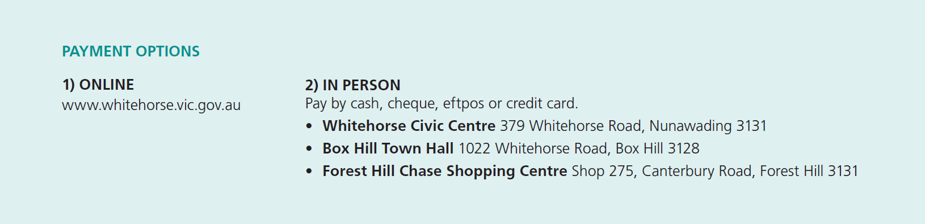

Signature: ________________________________________ Date: _______________________________________

Permit Conditions | - The permit fee must be paid before use  - The applicant must supply valid copies of the required documentation  - The permit is only valid at the nominated site location stated on the permit  - The permit is only valid for 12 months  - The permit is not transferrable:  - Permits are not to be leased, sold or given away  - No form of advertising of a permit for rent, lease, sale profit or other beneficial or fraudulent consideration of causing such an advertisement to be published is permitted  - At the conclusion of the permit period a new application form must be submitted  - The permit must be securely displayed so all details remain clearly visible through the passenger side of the front windscreen throughout the duration of parking  - Permit holders must comply with Victorian Road Rules at all times  - Permits are not valid in:  - Areas marked as no parking or no stopping including clearways during restriction times  - Permit restricted parking areas such as disabled persons’ parking areas, bus stops, taxi ranks, loading zones and construction zones  - Parking restriction areas of 30 minutes or less  - Prohibited areas such as across driveways, centre reservations, nature strips and footways  - In front of commercial, industrial or mixed-use areas  - A parking permit for a specific vehicle cannot be used in another vehicle  - Permits are not to be photocopied and the copies used in other vehicles  - The permit can only be used by vehicles that do not exceed 7.5 meters in length or 4.5 tonnes in gross weight or vehicles with a payload of 1500kg or more  - Permits cannot be used for motor homes, caravans, boats or earthmoving machinery/equipment  - The issue of a permit does not guarantee the availability of a parking space  - The permit may be suspended by a member of Victoria Police or by an authorised Council Officer for any reason at any time. No permit fee will be refunded
Breach of Permit Conditions | - The permit may be cancelled  - Fines may be issued  - Costs incurred by Council may be charged directly to the permit holder  - Goods or equipment may be impounded  - Future permit applications may be declined  - No refunds will be given where a permit is cancelled due to breach of its conditions  - Use of cancelled permits may result in an infringement being issued.
Council Considerations | In deciding whether to grant a permit the Council will take into consideration:  - Details supplied by the permit applicant  - The suitability of the supporting documentation for this application  - The applicant’s record in applying for similar permits and adherence to permit conditions  - The applicant is a resident of the property as detailed on the application form
How to submit your application? | - Via email by sending to: customer.service@whitehorse.vic.gov.au  - Via mail by sending to:  Community Safety, Whitehorse City Council, Locked Bag 2, Nunawading Delivery Centre, VIC 3110  - In person at one of the Whitehorse City Council Customer Service Centres (refer to Payment Options)
How long before you receive a response? | - Allow 10 business days  Note: The permit process may be delayed if the required documentation is not provided, is out of date or insufficient.
Unsuccessful applications | - You will be notified in writing and any permit replacement application fee will be refunded
Link to further information | https://www.whitehorse.vic.gov.au/residential-parking-permits

The personal information on this form is being collected by Council to enable the processing of this application and for the purpose of administration of relevant Acts, Regulations and Local Laws. The personal information will be used by Council for that primary purpose or directly related purposes only. The information will not be released unless required by law. The applicant may apply to Council for access and/or amendments of the information.

